State EV Deployment Plan Exception Requests

As part of the development and approval of State Plans, a State may submit a request for discretionary exceptions from the requirement that charging infrastructure is installed every 50 miles along designated Alternative Fuel Corridor highway and within 1 travel mile of the designated Alternative Fuel Corridor highway. Exceptions will be granted under very limited circumstances on a case-by-case basis, approved in conjunction with annual state plan certification. A State may apply for an exception to the 50-mile criteria, an exception to the 1-mile (proximity) criteria or both for any of four reasons:

Grid Capacity: | Delivering sufficient power to the charging site requires major upgrades to existing infrastructure
Geography: | Lack of necessary services or access to the site significantly compromise accessibility and/or functionality (e.g., roadway exits, necessary amenities)
Equity: | An alternate location that would still service travelers on the Interstate or Alternative Fuel Corridor would better support providing benefits to a disadvantaged community
Extraordinary Cost: | Costs to locate and operate a station at given site prevent its economic viability even with federal funding through NEVI or other sources

Exceptions to the 50-mile criteria will be valid for the year of the plan being certified; exceptions to the 1-mile criteria will be permanent upon commissioning of the charging site. 50-mile exceptions will be revisited annually as conditions change and State Plans are updated. Greater scrutiny will be applied to larger deviations from the distance requirements.

Through the Bipartisan Infrastructure Law, the NEVI program has funding appropriated in FY22-FY26. States are encouraged to focus on exception requests for conditions that they expect to persist through this timeframe. States interested in requesting a discretionary exception are encouraged to provide the information outlined in this template to enable an appropriate determination.

The exception requests may be submitted as a separate attachment to the State Plan or the information included below may be incorporated directly into the State Plan. States are encouraged to submit a completed template to the Joint Office of Energy and Transportation for review and preliminary feedback in advance of State Plan submittal. To submit the exception request in advance of the State Plan submittal send the MS Word or PDF file as an attachment to the DriveElectricSubmission email. Approved 50-mile exceptions from previous years can be resubmitted in the same form and only need to be modified if there is material change.

Methodology for Measuring Distances

50-mile criteria
The 50-mile distance is measured between one charging station (existing or proposed) along a designated AFC to the next charging station along the AFC. The 50-mile distance is the approximate driving distance between these sequential stations for both interchanges and intersections.

1-mile criteria
The 1-mile distance is the approximate driving distance from the intersection or interchange to the station location. The design of interchanges may vary significantly, but the following is a general example that can be used in determining distance:
- The 1-mile distance may be measured from the end of the exit ramp or loop. In other words, where the ramp/loop intersects or merges with the adjoining road (Figure 1). Whichever exit or ramp is nearest the station may be used.

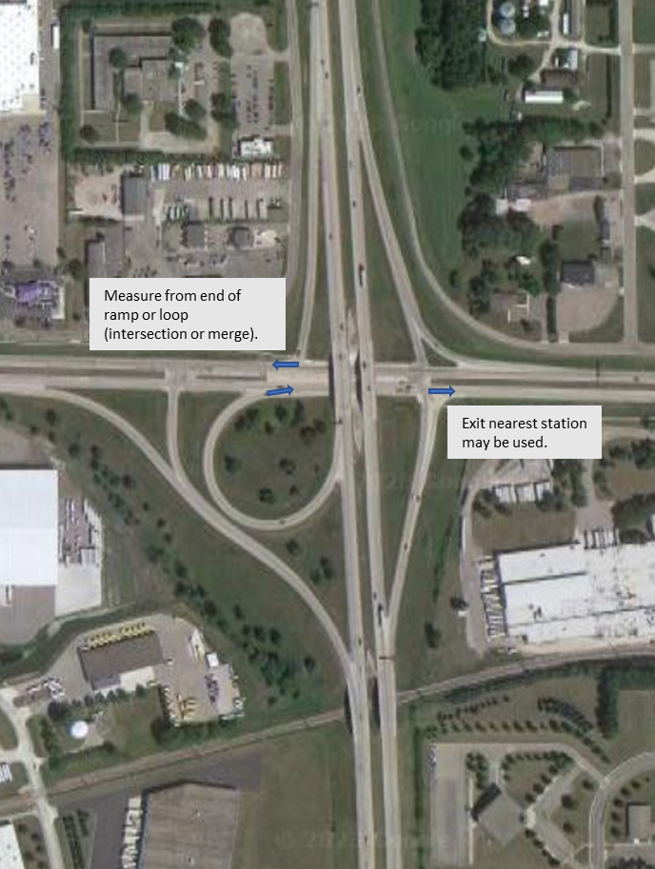

Exception Request Template

Summary of Requests
To complete this template, you will need to do three things:
- Populate the following table summarizing each of the exception requests;
- Insert the corresponding exception number on a map highlighting where the exception(s) is requested and the corresponding Alternative Fuel Corridor; and
- Provide, in paragraph form, the justification for exceptions as explained below
Exception #¹ | Type² | Distance of Deviation³ | Corresponding AFC⁴ | Reason for Exception Request⁵
 | - 50 miles apart  - 1 mile from exit | __ miles  __ miles |  | - Grid Capacity  - Geography  - Equity  - Extraordinary Cost
 | - 50 miles apart  - 1 mile from exit | __ miles  __ miles |  | - Grid Capacity  - Geography  - Equity  - Extraordinary Cost

- Indicate the number for this specific exception request that corresponds to the same number located on the map provided below.
- Select 50-mile or 1-mile distance exception.
- Note the distance of the exception request utilizing the methodology. For example, if the exception request is for a deviation of 5 miles from the 50-mile requirement, indicate 5-miles.
- List the corresponding AFC(s) for specific exception request.
- Check all reasons that apply.

[INSERT MAP]

Justification for Exception(s)

For each exception request in the table above, provide a justification in paragraph form:
- Explain why the request for an exception is being made, providing information to substantiate each of the allowable reasons that are applicable.
- Describe the alternative location that is being proposed and explain how the alternative being proposed to the requirements contributes to the completion of a national network of convenient, affordable, reliable, and equitable EV charging infrastructure.
- Reference or include any analysis that has been performed that substantiates the request for a discretionary exception.

